**VBA Excel macro to merge cells without losing data**

If you try to merge multiple cells in excel, it removes all data except the first line, To avoid this I have developed a macro.

There are two codes here, you can try either of options

Option 1

First code will prompt you to select the area which you want to merge. You will be prompted to select the area for merging.  Existing data will be replaced with merged data. For this code pls note that you will need to have a reference to the Forms library in Tools.  Tools -> References -> Select Microsoft Forms 2.0 Object library (if you don’t find it here, browse for **FM20.dll.**

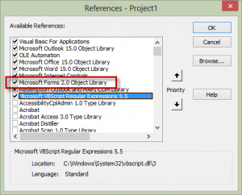

Option 2

Second code is simple, select the area which you want to merge and then run this macro.  Original data will be replaced with merged data.